# Task-03

1) Create on Bash script to check if a directory is available or not.

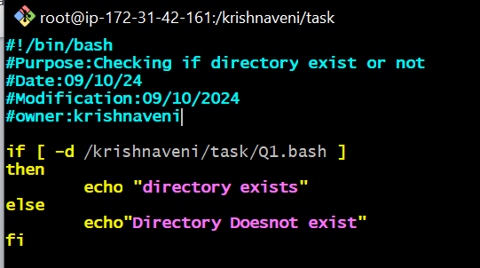:

o/p

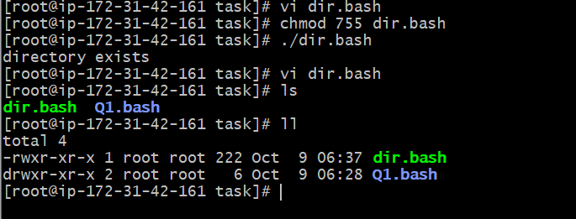

2) Create a bash script which will create multiple files. 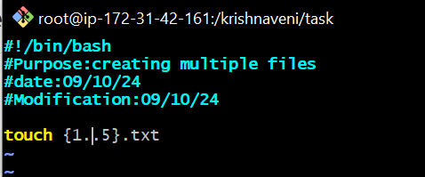

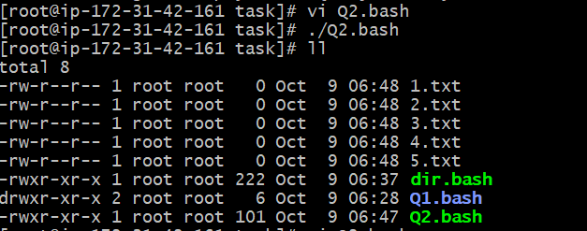

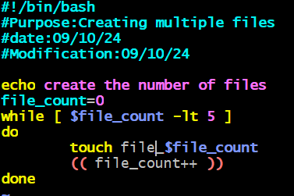

o/p:

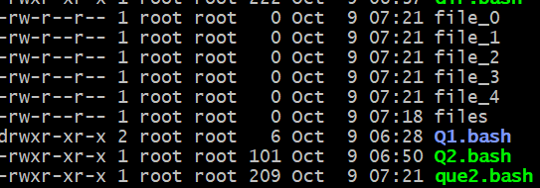

3) Create a bash script to take backup of a directory. 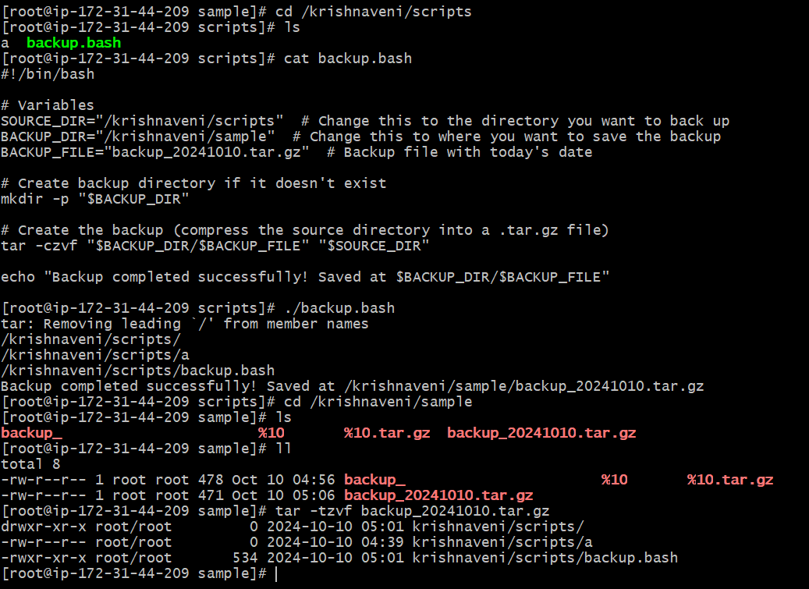

4) Create a bash script to install nginx in ec2 server. 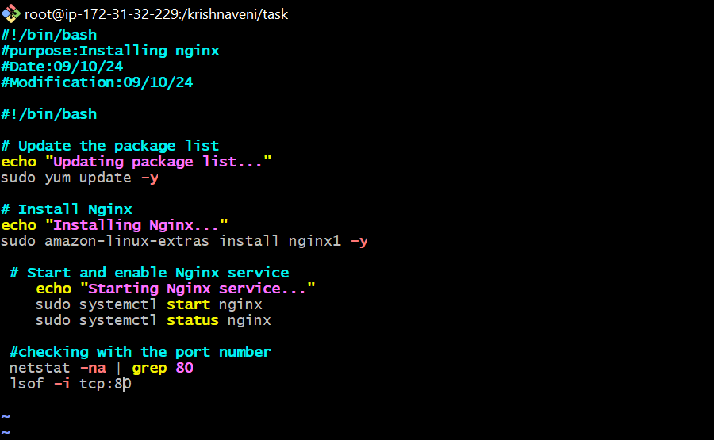

o/p:

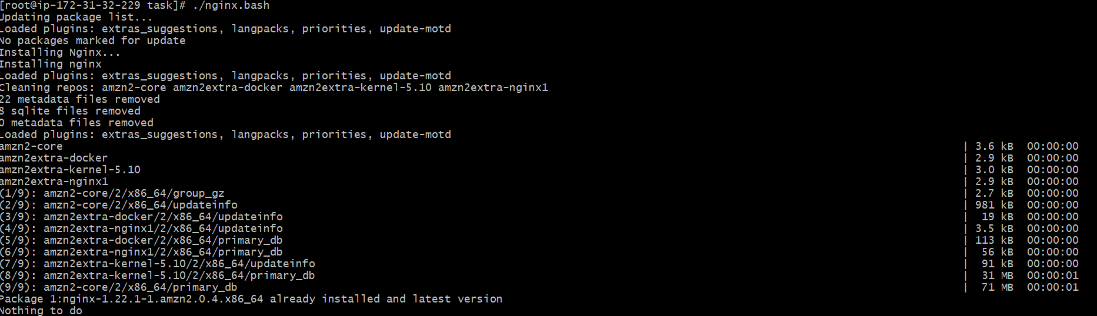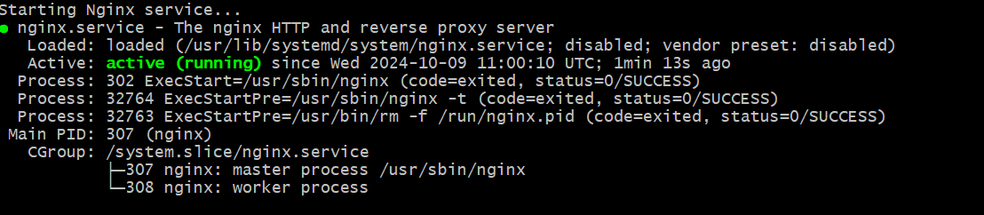

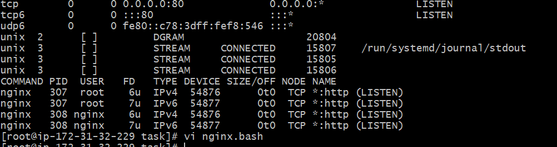

5) Create a bash script to install ApacheTomcat in ec2 server. 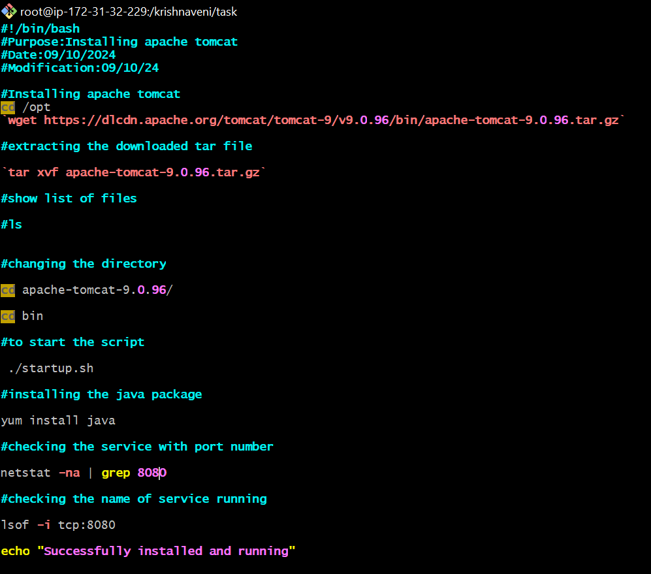

O/P:

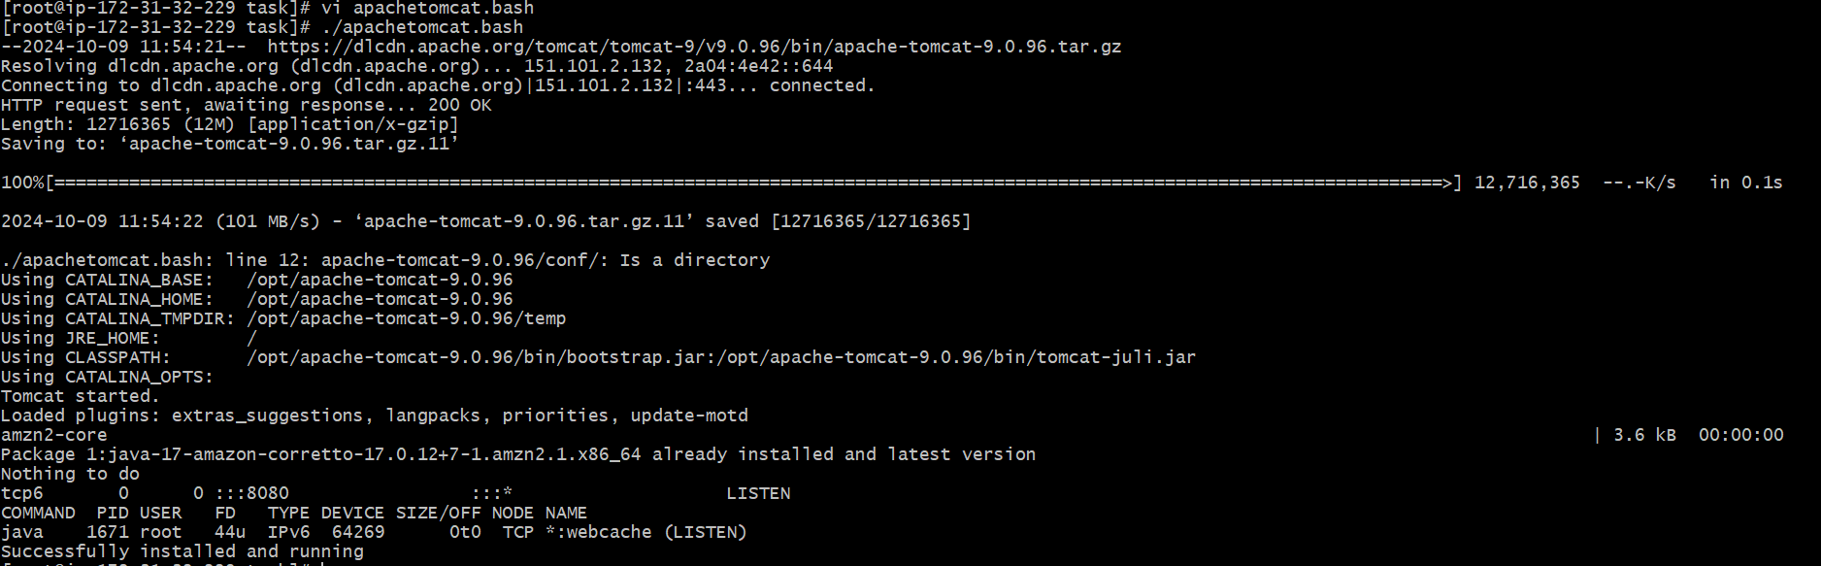

6) Create a bash script to check list if nginx service is running or not,if not running

then script should start the service. 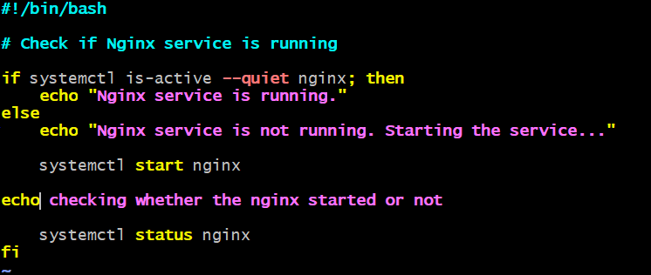

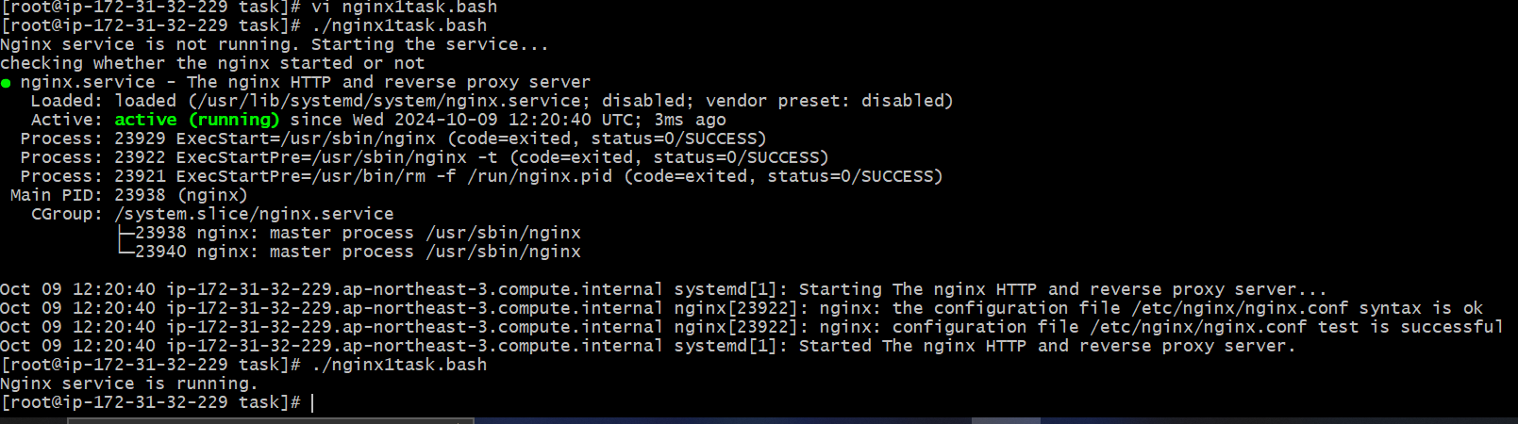

7) Create a bash script for calculator.

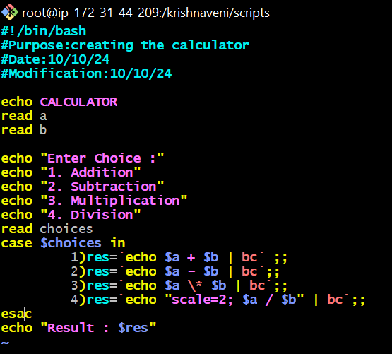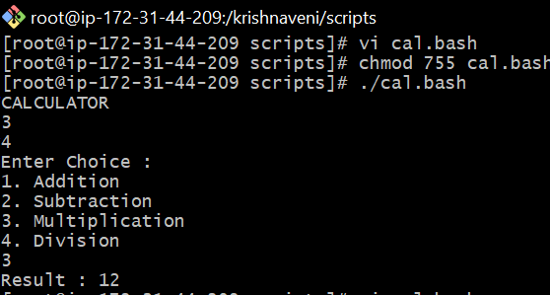

8) Create a bash script to check if directory is avaialble or not,if not then create a directory. 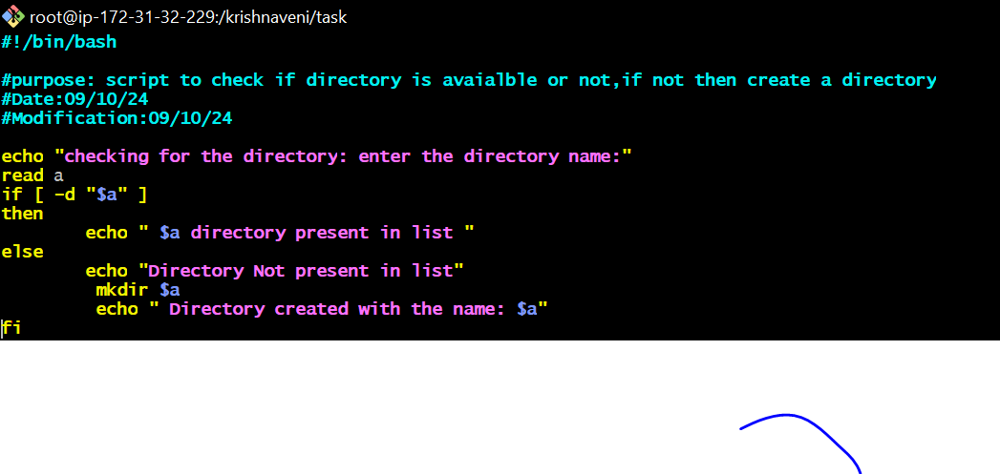

o/p

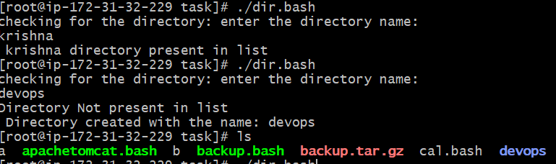

9) Create bash script to delete last 3 lines for a file.

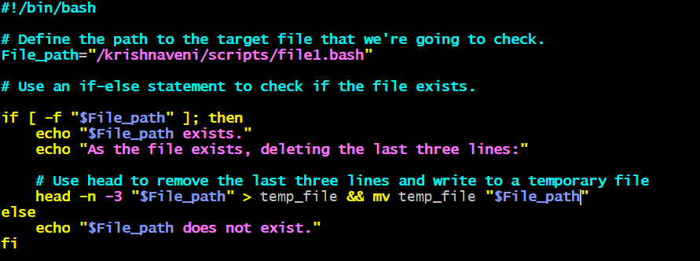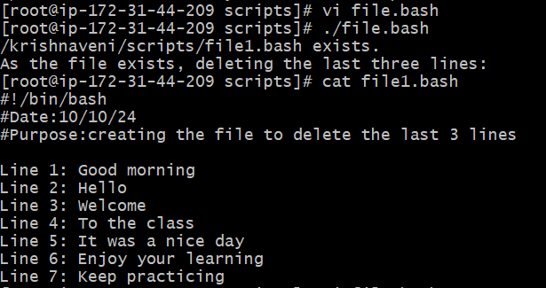

Exercise Crontab Entries :

1. April 5th Midnight



1. 5 th of Every November,Jan,June if it is a Thursday

. 

1. At 05 and 27th minutes of 9,10,11 hours every

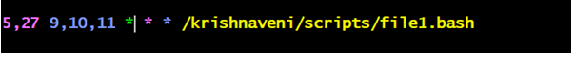

1. 34 min. of 9th hour on 15th Aug.



1. Every midnight



1. Every Weekend ( Saturday night 11.59 )



1. After every reboot

